**ASSIGNMENT FINAL REPORT**

|  |  |  |  |
| --- | --- | --- | --- |
| **Qualification** | **BTEC Level 5 HND Diploma in Computing** | | |
| **Unit number and title** | **Unit 3: Professional Practice** | | |
| **Submission date** |  | **Date Received 1st Submission** |  |
| **Re-submission Date** |  | **Date Received 2nd Submission** |  |
| **Student Name** | Duong Hong Duc | **Student ID** | BH01425 |
| **Class** | SE07101 | **Assessor name** | Dinh Van Dong |
| **Plagiarism**  Plagiarism is a particular form of cheating. Plagiarism must be avoided at all costs and students who break the rules, however innocently, may be penalised. It is your responsibility to ensure that you understand correct referencing practices. As a university level student, you are expected to use appropriate references throughout and keep carefully detailed notes of all your sources of materials for material you have used in your work, including any material downloaded from the Internet. Please consult the relevant unit lecturer or your course tutor if you need any further advice.  **Student Declaration**  I certify that the assignment submission is entirely my own work and I fully understand the consequences of plagiarism. I declare that the work submitted for assessment has been carried out without assistance other than that which is acceptable according to the rules of the specification. I certify I have clearly referenced any sources and any artificial intelligence (AI) tools used in the work. I understand that making a false declaration is a form of malpractice. | | | |
|  |  | **Student’s signature** | Duc |

**Grading grid**

|  |  |  |  |  |  |  |  |  |
| --- | --- | --- | --- | --- | --- | --- | --- | --- |
| P5 | P6 | P7 | P8 | P9 | M4 | M5 | D3 | D4 |
|  |  |  |  |  |  |  |  |  |

**ASSIGNMENT GROUP WORK**

|  |  |  |  |
| --- | --- | --- | --- |
| **Qualification** | **BTEC Level 5 HND Diploma in Computing** | | |
| **Unit number and title** | **Unit 3: Professional Practice** | | |
| **Submission date** |  | **Date Received 1st submission** |  |
| **Re-submission Date** |  | **Date Received 2nd submission** |  |
| **Group number:** | **Student names & codes** | **Final scores** | **Signatures** |
| Do Dang Khoa |  | Khoa |
| Duong Hong Duc |  | Duc |
| Du Dinh Quang Huy |  | Huy |
| Vu Bui Duc Anh |  | Anh |
|  |
| **Class** | SE07101 | **Assessor name** | Dinh Van Dong |
| **Plagiarism**  Plagiarism is a particular form of cheating. Plagiarism must be avoided at all costs and students who break the rules, however innocently, may be penalised. It is your responsibility to ensure that you understand correct referencing practices. As a university level student, you are expected to use appropriate references throughout and keep carefully detailed notes of all your sources of materials for material you have used in your work, including any material downloaded from the Internet. Please consult the relevant unit lecturer or your course tutor if you need any further advice.  **Student Declaration**  I certify that the assignment submission is entirely my own work and I fully understand the consequences of plagiarism. I declare that the work submitted for assessment has been carried out without assistance other than that which is acceptable according to the rules of the specification. I certify I have clearly referenced any sources and any artificial intelligence (AI) tools used in the work. I understand that making a false declaration is a form of malpractice. | | | |

|  |  |  |  |  |  |  |  |  |
| --- | --- | --- | --- | --- | --- | --- | --- | --- |
| P1 | P2 | P3 | P4 | M1 | M2 | M3 | D1 | D2 |
|  |  |  |  |  |  |  |  |  |

**OBSERVATION RECORD**

|  |  |  |  |  |  |  |
| --- | --- | --- | --- | --- | --- | --- |
| **Student** |  | | | | | |
| **Description of activity undertaken** | | | | | | |
|  | | | | | | |
| **Assessment & grading criteria** | | | | | | |
|  | | | | | | |
| **How the activity meets the requirements of the criteria** | | | | | | |
|  | | | | | | |
| **Student signature:** |  | | **Date:** |  | | |
| **Assessor signature:** |  | | **Date:** |  | | |
| **Assessor name:** |  | | | | | |
| ** Summative Feedback:  Resubmission Feedback:** | | | | | | |
| **Grade:** | | | **Assessor Signature:** | | | **Date:** |
| **Internal Verifier’s Comments:** | | | | | | |
| **Signature & Date:** | | | | | | |

Table of Contents

I. Introduction 8

II. Content 8

1. Different communication styles and formats. 8

1.1. Discuss the definition of communication 8

1.2. Explain verbal 10

1.3. Explain non-verbal communication 11

2. Demonstrate effective design and delivery of a training event for a given target audience and show effective time-management skills in planning an event. 13

2.1. Discuss the definition and importance of time management. 13

2.2 Planning a Training Event 15

2.3 Demonstrate the use of different problem-solving techniques in the design and delivery of an event. 17

2.4 Problem solving techniques and examples 19

2.5 Analyse problems and give solutions in the event and teamwork (List issues you and your teams faced through the event, or during working in group time. What are the technique solutions for thoes issues) 24

2.6 Demonstrate that critical reasoning has been applied to the design and delivery of the event. (P4) (What is critical reasoning? Explain why it important in our daily lives, specially working in group.) 25

2.7 Apply to given solution (Did you apply critical reasoning in the last group working time, why did you use and how did you use) 26

3. Discuss the importance of team dynamics 27

3.1 definition of team dyanamics 27

3.2 Assess Benne and Sheats group roles 27

3.3 Evaluate the importance of team dynamics in the success/failure of group work 28

3.4 Critical evaluate the roles of each member in my team 29

4. Designing a website or application 29

5. Discuss the importance of CPD and its contribution to own learning and motivation. 30

5.1 Give definition of CPD 30

5.2 Explain why CPD is important 30

5.3 Discuss CPD contribution to own learning 31

6. Review different motivational theories and the impact they can have on performance in the workplace. 31

6.1 definition of motivation 31

6.2 Discuss expectancy model’s Alderfer 31

6.3 Discuss Vroom’s motivational theory 31

6.4 Analyse the impact of motivational theories on performance of workplace 31

7. Produce a development plan that outlines responsibilities, performance objectives and required skills for future goals. 31

7.1 State your goals 31

7.2 Development plan 31

III. Conclusion 32

IV. References 32

# I. Introduction

In the fast-paced digital age, teenagers are constantly on the lookout for tools that can make their lives easier, more fun, and more productive. With this in mind, we've developed a groundbreaking application designed specifically for teenagers, catering to their unique needs and preferences. Our application, compatible with smartphones, tablets, and laptops, promises to be a game-changer for anyone looking to enhance their digital experience.

The mission is clear: we need to spread the word about this innovative product and gain a substantial user base quickly. Our goal is to have 1000 active users within just three months. Achieving this ambitious target requires a well-coordinated promotional effort, leveraging the skills and talents of our friends and peers.

To kickstart this mission, we will host a comprehensive training event aimed at explaining the features and benefits of our application to potential users. This event will not only introduce our product but also equip attendees with the knowledge to use it effectively and share their positive experiences with others.

Our talented friends will play a crucial role in this endeavor. They will help create visually appealing graphic demos that highlight the key aspects of our application. These demos will be essential for capturing the interest of our target audience and attracting funding from supporters within our school, neighborhood, and beyond.

Through this introduction, we aim to outline our strategy for launching and promoting our application, ensuring that we reach our goal of 1000 active users in the shortest time possible. By leveraging the collective skills and enthusiasm of our team, we are confident that we can make a significant impact and bring our innovative product to the forefront of the digital landscape for teenagers.

# II. Content

## 1. Different communication styles and formats.

### 1.1. Discuss the definition of communication

**Definition**

It is the process of two or more people or groups exchanging information, ideas, thoughts, and feelings. It is a basic human activity that enables individuals to communicate with one another and exchange ideas, feelings, and experiences.

**Type**

There are a various Categories of Communication, for ex:

* Verbal Communication

Figure 2

* Nonverbal Communication
* Communication Across Cultures
* Visual Communication
* Electronic communication

*Figure 1* 

1.2. Explain verbal

**communication**

**Definition**

Verbal communication is a type of communication where we use spoken and written words to get our message and information across to the other person.



*Figure 3*

**Example of verbal communication**

* Communication creates job satisfaction — When a company advocates for open communication between its employees, no matter their rank or seniority, it helps the company’s employees to feel that their opinions are heard and valued.
* Communication leads to fewer conflicts — Workplace conflicts are common, but when a company implements and advocates for open communication in the office, it is easier to resolve misunderstandings.
* Communication strengthens relationships — If a company’s goal is to have a healthy and productive collective, then practicing open communication can help to achieve that goal.
* Communication leads to more productivity — When miscommunication happens in the workplace, it usually affects productivity in the office, and more often than not, the tasks involved are delayed.



*Figure 4*

### 1.3. Explain non-verbal communication

**Definition**

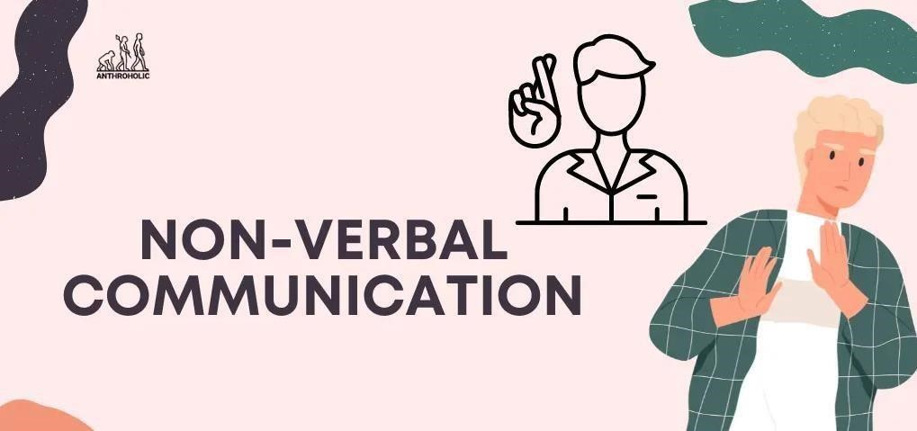

*Figure 5*

The term "non-verbal communication" describes the exchange of information and messages without the

use of spoken words. It includes a wide range of actions, clues, and signals that are essential to understanding and having successful interpersonal interactions.

**Example**

**The primary components of non-verbal communication include:**

Kinesics (body language ): is the study of how people express their intentions, attitudes, and feelings via their bodily postures, gestures, and movements. An open posture, on the other hand, might convey warmth and receptivity. For example, crossing one's arms may imply defensiveness.



*Figure 6*

Facial Expressions: It is important to use facial muscles to convey emotions like happiness, sorrow, anger, surprise, fear, and contempt. These phrases frequently cut over cultural divides and are understood by everybody.

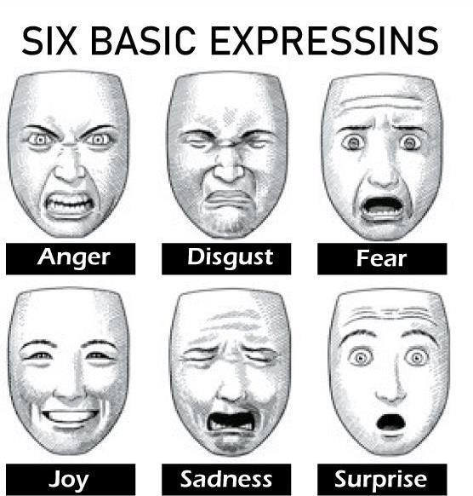

*Figure 7*

Oculesics (Eye Contact): Controlling the direction and length of one's glance may convey different messages about one's degree of interest, respect, or dominance. Maintaining eye contact can convey assurance and genuineness, but avoiding it could suggest unease or avoidance.

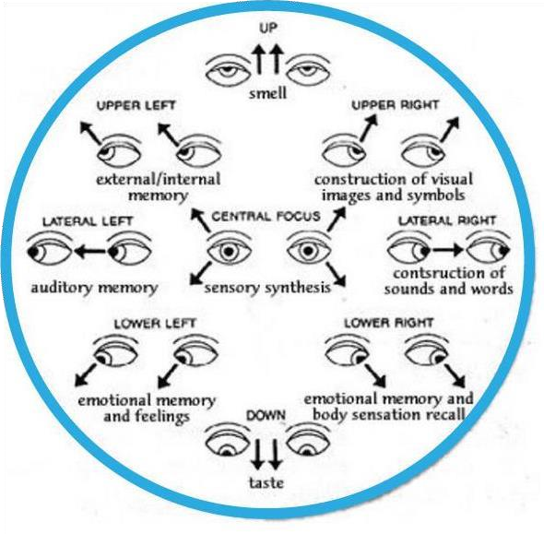*Figure 8*

Haptics: This refers to using touch to communicate, such hugs, handshakes, back pats, or comforting touches on the arm. Touch has diverse connotations and social acceptance depending on the culture and setting.



*Figure 9*

## 2. Demonstrate effective design and delivery of a training event for a given target audience and show effective time-management skills in planning an event.

### 2.1. Discuss the definition and importance of time management.

**Definition:**

Time management is the act of allocating, planning, and calculating how much time to spend on different tasks. It involves the intentional division of time among various tasks and obligations in order to maximize efficiency and output. People with strong time management skills can set realistic goals, prioritize their tasks, and organize their days to maximize their available time.



*Figure 10*

**Importance of time management:**

Enhanced Productivity: By setting priorities for crucial tasks and cutting down on procrastination, effective time management enables people to finish more work in less time.

Stress Reduction: By preventing last-minute scrambling and easing the tension associated with approaching deadlines, a well-defined timetable promotes a more composed and organized work environment.

Better Prioritization: With a systematic approach, less urgent jobs may be planned appropriately and vital tasks can be tackled swiftly, leading to enhanced decision-making.

Better Work-Life Balance: Time management skills guarantee that there is enough time for both work and personal obligations, reducing burnout and enhancing general wellbeing.

Goal Achievement: Consistent progress and ultimate goal accomplishment are facilitated by breaking down big goals into smaller, time-bound activities.

Improved Work Quality: Concentrating on a single job at hand without interruptions frequently yields better work with more attention to detail.

More Opportunities: Managing present obligations well creates time for new endeavors, education, and skill improvement, which promotes both professional and personal development.

Improved Self-Discipline: Consistent time management practice improves habits and self-control, which are helpful in many facets of life.

Meeting Deadlines: Managing your time well to consistently meet deadlines improves your reputation and dependability in social, professional, and academic settings.

Trimming Procrastination: Having a well-organized schedule and distinct due dates keeps one on task and reduces the propensity to put off work.

### 2.2 Planning a Training Event

### This June, we will start a project to create an “musical dream” automatic music playback program with the participation of four members: me, Duc Anh, Quang Huy and Hong Duc. First, after creating this program, I hope everyone will be able to listen to their favorite music without ads or consuming RAM. Satisfy user experience. My program will be available to everyone, including my friends, teachers, and anyone outside of school. The program will start on August 16, 2024 at FPT BTEC College.

Day 1 (August 14, 2024):

* The program will begin collecting user opinions by using google forms to create a survey about users' interest in the program. The deadline for collecting comments will be 9 a.m. on August 15.

Day 2 (August 15, 2024):

* After 9 a.m.: After collecting opinions, the development team will begin designing the program and its interface, including adding ad blocking software or remembering your played music. user. All four people will focus on designing the program together, from writing code to designing the program interface.

Day 3 (August 16, 2024):

* 12:00 noon: Officially open the trial version of the program, receive opinions and comments from users, fix errors reported by users and update additional features as requested by users.

Day 4 (August 17, 2024):

* After receiving opinions and comments from users, fixing and updating additional features for the program, we will release the official version of the program.

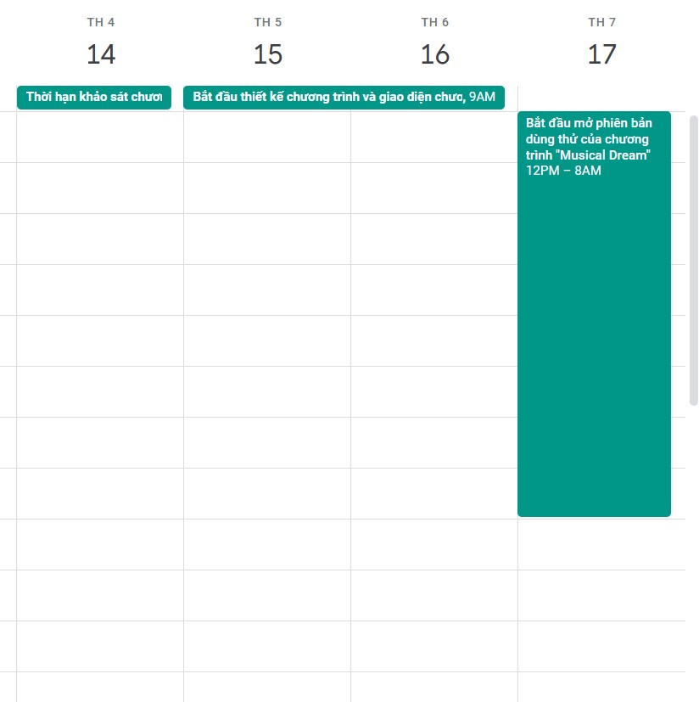

*Figure 11*

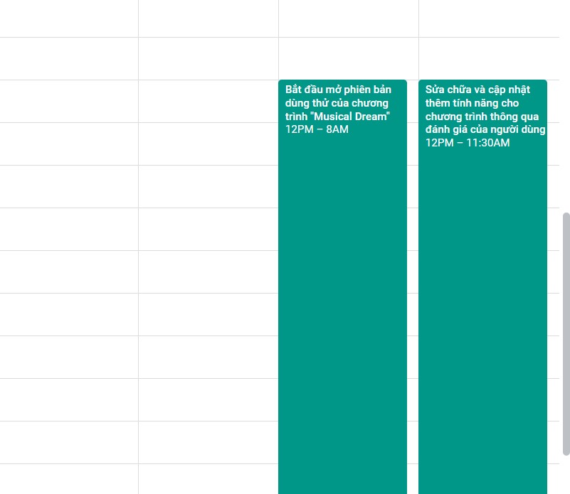

*Figure 12*

This is the Google Calendar design I made to prepare for the event. Along with an estimated budget to award prizes to the teams participating in the games and achieving 1st, 2nd, and 3rd places in the program: 2,500,000 VND for first place, 2,000,000 VND for second place, and 1,500,000 VND for third place. The total estimated cost for this event is about 12,000,000 VND.

### 2.3 Demonstrate the use of different problem-solving techniques in the design and delivery of an event.

### Discuss the definition of problem-solving skills

- Definition

Problem solving is the act of defining a problem; determining the cause of the problem; identifying, prioritizing, and selecting alternatives for a solution; and implementing a solution.

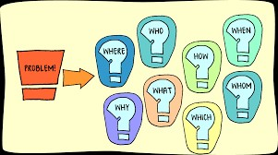

Figure 13

Problem solving process

1.Define the problem

* + 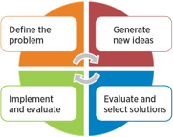Differentiate fact from opinion

Figure 14

* + Specify underlying causes
  + Consult each faction involved for information
  + State the problem specifically
  + Identify what standard or expectation is violated
  + Determine in which process the problem lies
  + Avoid trying to solve the problem without data

1. Generate alternative solutions 
   * Postpone evaluating alternatives initially
   * Include all involved individuals in the generating of alternatives
   * Specify alternatives consistent with organizational goals
   * Specify short- and long-term alternatives
   * Brainstorm on others' ideas
   * Seek alternatives that may solve the problem
2. Evaluate and select an alternative
   * Evaluate alternatives relative to a target standard
   * Evaluate all alternatives without bias
   * Evaluate alternatives relative to established goals
   * Evaluate both proven and possible outcomes
   * State the selected alternative explicitly
3. Implement and follow up on the solution
   * Plan and implement a pilot test of the chosen alternative
   * Gather feedback from all affected parties
   * Seek acceptance or consensus by all those affected
   * Establish ongoing measures and monitoring
   * Evaluate long-term results based on final solution

### 2.4 Problem solving techniques and examples

**Brainstorming**

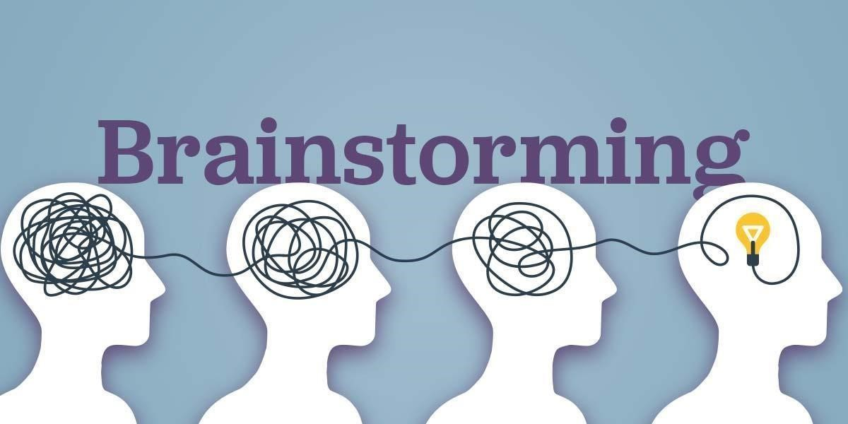 *Figure 15*

The goal of the brainstorming technique is to generate a large number of solutions for problems. Participants are encouraged to think freely and provide as many recommendations as they can in order to foster an environment where creative solutions could emerge. Evaluation and criticism of ideas are delayed until after the brainstorming session in order to encourage unconstrained innovation.

**Example**:

**Problem**: An educational institution seeks to improve student engagement in online learning environments.

**Brainstorming Session**: Academics and staff come together to discuss ideas and come up with concepts like adding gamification components, providing online office hours, making interactive course materials, combining social learning platforms, and designing customized learning routes. By holding off on passing judgment, participants are free to provide creative fixes. After the meeting, the group assesses each idea's viability and possible effect in order to put the most promising ones into practice.

**Root Cause Analysis (RCA)**

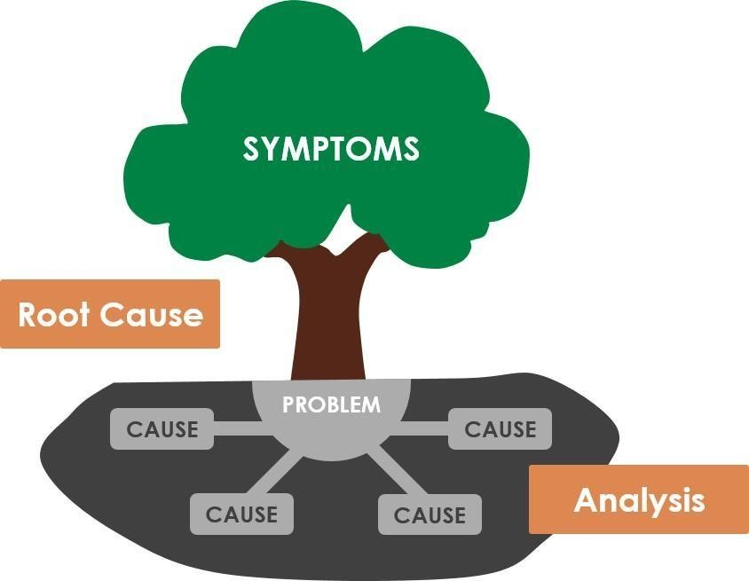 *Figure 16*

Rather than treating the symptoms of an issue, Root Cause Analysis is a methodical procedure that finds the fundamental reasons of the issue. A popular root cause analysis technique called the "5 Whys" method is asking "why" several times in order to uncover the core problem.

**Example**:

**Problem**: A software development company experiences frequent delays in project delivery.

**RCA Process**:

* **Why** are projects delayed? Because tasks often exceed estimated completion times.
* **Why** do tasks exceed estimated times? Because initial project estimates are inaccurate.
* **Why** are project estimates inaccurate? Because the team lacks detailed project requirement definitions.
* **Why** are requirement definitions lacking? Because the client feedback process is inefficient.
* **Why** is the client feedback process inefficient? Because there is no structured framework for regular client communication and feedback.

Identifying the root cause—inefficient client feedback processes—enables the company to implement a structured communication framework, ensuring more accurate project estimates and timely deliveries.

**SWOT Analysis**

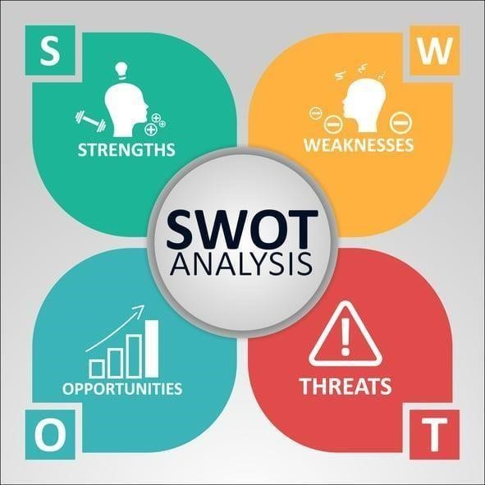

*Figure 17*

A strategic planning technique called a SWOT analysis is used to assess the advantages, disadvantages, opportunities, and threats of a certain project or commercial venture. This method aids in comprehending the problem and its solutions by taking into account both external and internal variables.

**Example**:

**Problem**: A startup company wants to enter a new market.

**SWOT Analysis Process**:

* **Strengths**: Innovative product, experienced team, strong brand identity.
* **Weaknesses**: Limited financial resources, lack of market presence.
* **Opportunities**: Growing demand for the product, limited competition, potential partnerships. **- Threats**: Economic downturn, regulatory changes, potential new competitors.

The startup may create plans to harness its strengths, reduce its weaknesses, seize opportunities, and defend against threats by doing a SWOT analysis. For example, the corporation may choose to develop strategic alliances to expand its market presence and pursue investment to augment its financial resources.

**Six thinking hats**

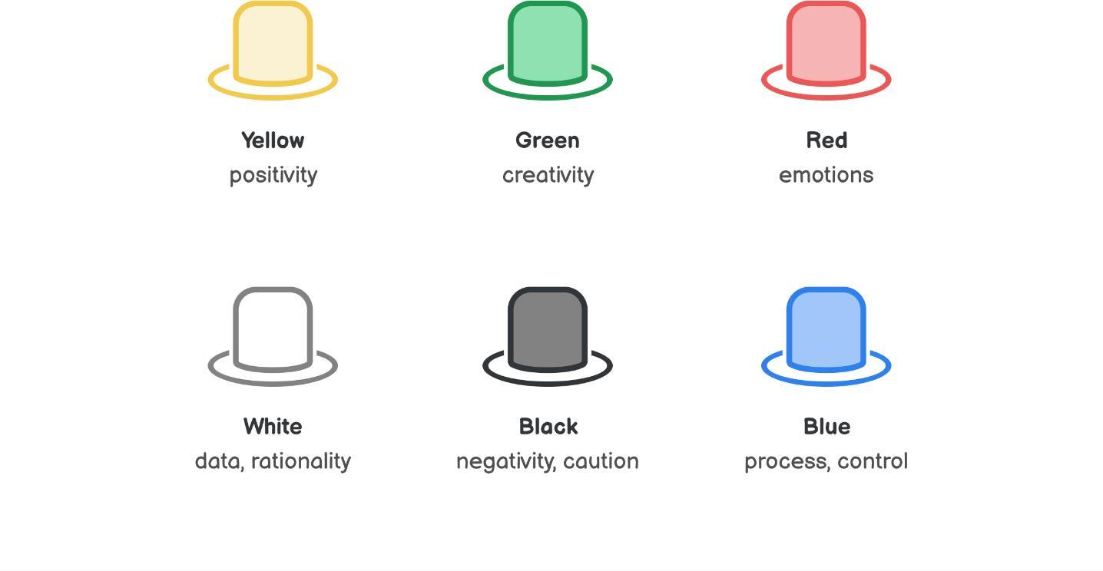

*Figure 18*

The Six Thinking Hats are a set of problem-solving techniques developed by Edward de Bono. It comprises looking at a problem from six different perspectives, each represented by a different colored hat. This approach ensures that all aspects of the problem are considered, which encourages in-depth study and helps to overcome cognitive biases.

**Example**:

**Problem**: A company is facing declining customer satisfaction.

**Six Thinking Hats Process**:

* **White Hat (Facts)**: Focus on the available data and information.
  + **Data**: Recent customer satisfaction surveys indicate a 15% drop in satisfaction over the past year. Common complaints include slow service and poor product quality.
* **Red Hat (Emotions)**: Explore the emotional responses and intuitions.
  + **Emotions**: Customers feel frustrated and undervalued. Employees also feel demotivated due to increased complaints.
* **Black Hat (Caution)**: Identify potential problems and risks.
  + **Risks**: Continued decline in satisfaction could lead to a loss of loyal customers, negative reviews, and decreased revenue.
* **Yellow Hat (Optimism)**: Consider the potential benefits and positive outcomes.
  + **Benefits**: Improving customer satisfaction could enhance brand loyalty, attract new customers, and increase profits.
* **Green Hat (Creativity)**: Generate innovative solutions and alternatives.
  + **Ideas**: Implement a new customer service training program, introduce a customer feedback loop, upgrade product quality, and streamline service processes.
* **Blue Hat (Process)**: Manage the thinking process and ensure that all perspectives are covered.
  + **Process**: Schedule regular review meetings to monitor progress and adjust strategies as needed. Ensure that each hat's perspective is given equal consideration.

The company may introduce a comprehensive plan that includes improved product quality controls, new customer engagement initiatives, and more training for customer service agents by implementing the methodologies' results. A more successful outcome is ensured by this comprehensive approach, which tackles all aspects of the problem.

### 2.5 Analyse problems and give solutions in the event and teamwork (List issues you and your teams faced through the event, or during working in group time. What are the technique solutions for thoes issues)

**Hardly when talking:**

Team members may have difficulty understanding and communicating ideas clearly, leading to misunderstandings and conflicts.

Solution: Set up clear rules to ensure everyone understands how and when to communicate within the group, create a specific deadline, organize face-to-face meetings **Uneven division of work:**

Some members may feel that work is not divided fairly, leading to dissatisfaction and reduced motivation.

Solution: Assign work clearly based on the abilities and strengths of each member.

**Poor time management ability:**

One or more members may have difficulty managing their time, leading to failure to complete work on time.

Solution: Make a detailed plan with specific timelines to easily track and complete work on time.

**Personal conflicts:**

Members may not get along personally, affecting the group's performance.

Solution: Create an open environment so members can discuss and resolve conflicts directly or through a mediator honestly.

 *Figure 19*

### 2.6 Demonstrate that critical reasoning has been applied to the design and delivery of the event. (P4) (What is critical reasoning? Explain why it important in our daily lives, specially working in group.)

### 

### Discuss the definition and evaluate the importance of critical reasoning (Define “critical reasoning”, explain why it is crucial in school, work, or daily lives.)

a) Definition

Critical reasoning is the process of analyzing, evaluating, and criticizing ideas, arguments, and information to achieve a deeper and more accurate understanding of an issue. b) Important

Critical reasoning is important in our everyday lives because it improves our ability to defend personal views, communicate effectively, resolve conflicts and debate constructively, and develop critical thinking. logic and creativity. Drawing conclusions based on logical analysis helps us improve our thinking. Someone once said "There must be debate to get results".

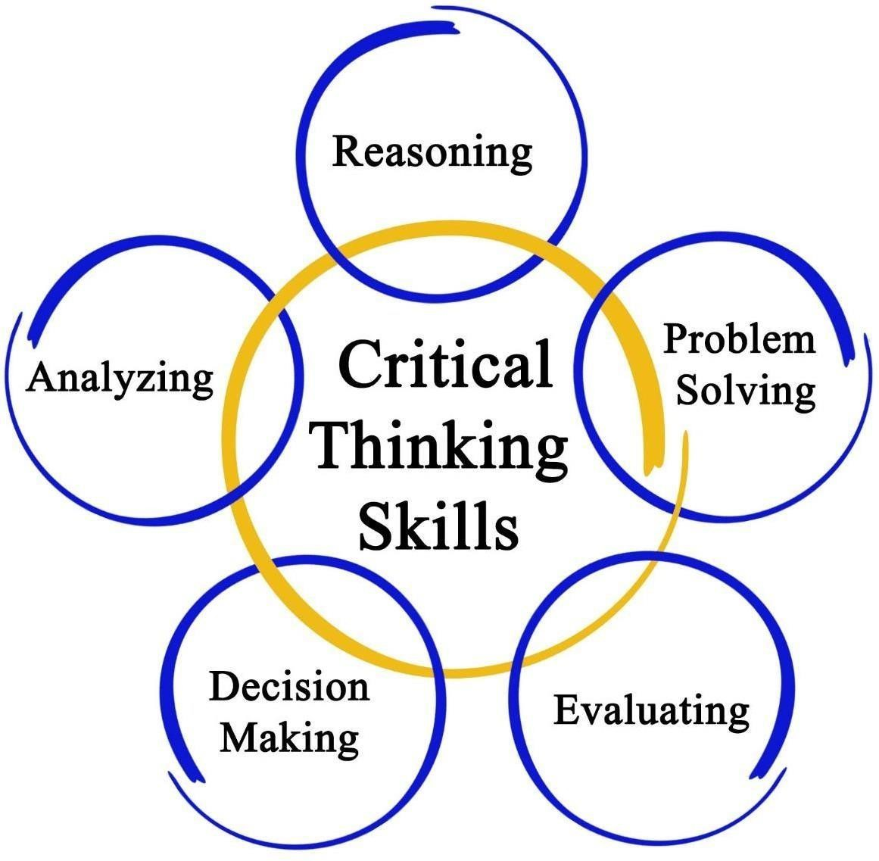

*Figure 20*

### 2.7 Apply to given solution (Did you apply critical reasoning in the last group working time, why did you use and how did you use)

Critical reasoning is important in our everyday lives because it improves our ability to defend personal views, communicate effectively, resolve conflicts and debate constructively, and develop critical thinking. logic and creativity. Drawing conclusions based on logical analysis helps us improve our thinking. Someone once said "There must be debate to get results"

I used critical reasoning during group work. Because my team had some problems with my management style, such as because I divided the work unevenly and did not clearly explain the tasks specifically to each person, but I solved them. resolved by understanding each person's strengths and weaknesses and focusing on explaining what they need to do in the group. I am the person who moderates each group member's content to see if it meets the standards or not, and I clearly show them where their content is wrong or lacking. Convince them to try to rework the content more carefully through critical reasoning.

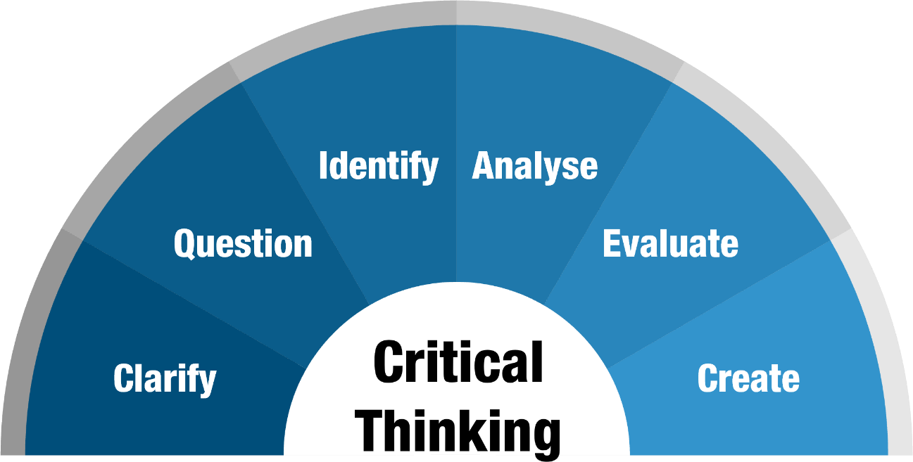

*Figure 21*

## 3. Discuss the importance of team dynamics

### 3.1 definition of team dyanamics

Definition

Team dynamics refers to the relationships and interactions between team members that can affect their productivity and performance. It encompasses how team members communicate, collaborate, and coordinate their efforts to achieve a shared goal.

Key element

* Communication
* Trust
* Roles and responsibilities
* Diversity and Inclusion
* Conflict Resolution

### 3.2 Assess Benne and Sheats group roles

Every organisation involves departments and teams, and it’s not always easy to predict how relationships between team members will turn out. After all, interpersonal relationships are often complex. Having highly skilled employees with skills that perfectly suit their roles and tasks doesn’t necessarily mean collaboration will go smoothly.

Some common role

- Initiator

This person actively contributes to the work and proposes original ideas or identifies unique ways of achieving the final goal.

- Information Seeker

This person tracks down all the necessary information relating to a specific project.

- Information Giver

The information seeker is also often the information giver; this person communicates the information to his team.

- Opinion Seeker

Within the Benne and Sheats group roles, this is often an opinionated team member who will seek clarity and the opinions of others.

- Elaborator

This person is able to explore and expand upon the ideas of others.

- Orienter

This person evaluates and clarifies the position of the team.

### 3.3 Evaluate the importance of team dynamics in the success/failure of group work

There is some factor that can affect the success/failure of group work ,that include:

- Leadership

A top-down approach is crucial when trying to optimize team dynamics. Leaders need to demonstrate effective leadership to boost team dynamics.

- Organizational Culture

Employees need to feel psychologically safe to show their true potential at work.

- Personalities

Individual personalities can affect how team members interact and collaborate, their communication styles, and their ability to resolve conflicts.

### 

### 3.4 Critical evaluate the roles of each member in my team

Khoa: initiator

Duc: infor seeker

Duc Anh: opinion seeker

Quang Huy: Elaborator

## 4. Designing a website or application

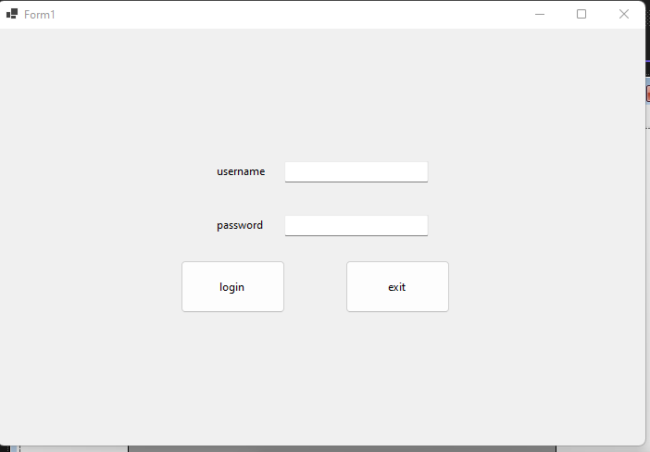

*Figure 1:login form*

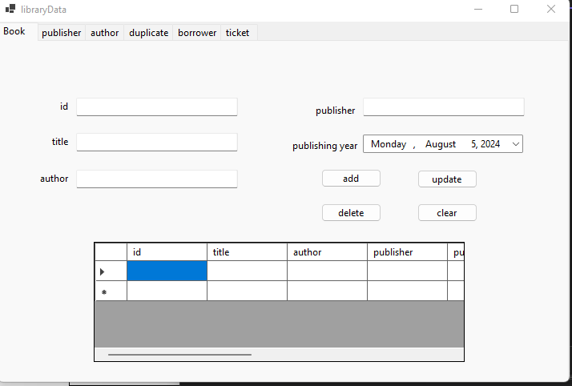

*Figure 2:library management form*

## 5. Discuss the importance of CPD and its contribution to own learning and motivation.

### 5.1 Give definition of CPD

CPD stands for Continuing Professional Development. It refers to the process of tracking and documenting the skills, knowledge and experience that you gain both formally and informally as you work, beyond any initial training. It’s a record of what you experience, learn and then apply.

### 5.2 Explain why CPD is important

CPD may be a requirement of membership of a professional body. It can help you to reflect, review and document your learning and to develop and update your professional knowledge and skills. It is also very useful to:

* provide an overview of your professional development to date
* remind you of your achievements and how far you’ve progressed
* direct your career and help you keep your eye on your goals
* uncover gaps in your skills and capabilities
* open up further development needs
* provide examples and scenarios for a CV or interview
* demonstrate your professional standing to clients and employers
* help you with your career development or a possible career change.

### 5.3 Discuss CPD contribution to own learning

Cpd help me a lot in my learning as it help set up my goal and good strategies for future ,it also help me prepare every skill I need for my career in future

## 6. Review different motivational theories and the impact they can have on performance in the workplace.

### 6.1 definition of motivation

The term motivation describes why a person does something. It is the driving force behind human actions. Motivation is the process that initiates, guides, and maintains goal-oriented behaviors.

### 6.2 Discuss expectancy model’s Alderfer

After discuss, I conclude that Alderfer’s ERG Theory provides a multifaceted framework for understanding human needs and motivations, making it an invaluable tool for managers and educators alike. By taking a more nuanced approach to meet the various needs of employees or students, professionals in these fields can engender a more productive and satisfying experience for everyone involved.

### 6.3 Discuss Vroom’s motivational theory

After discuss, I conclude that vroom motivational theory is a very reliable motivate theory as it help both individual and group have motivation to do something by point out 3 factors like valence,expectancy,instrumentality , thereby everyone read will know what exactly they must do to get motivation

### 6.4 Analyse the impact of motivational theories on performance of workplace

after reading both theories I realize at workplace , we need something value like reward for motivation, but we also only need something that very simple like family ,food ,etc ,…… all that would just a few in dozan of reason for motivation, but that alone would be enough because too many things would be too much and don’t have any thing for motivation would led to our performance decrease, so here the thing, anyone of us should have at least one thing for motivation because have motivation will help your life more meaning and it is one the factor for you to put effort in something

## 7. Produce a development plan that outlines responsibilities, performance objectives and required skills for future goals.

### 7.1 State your goals

For short term: I will do my best to graduate college

For mid term: I will try to get a job correct to my branch after graduate

For long term: I will try to make as much money as I could so I can go travel

### 7.2 Development plan

Short term goal: I will not relearn any subject and study hard thereby graduate with good degree

Mid term : to prepare for the job, I need college degree and also good English degree and also some skill so I can get hired

Long term : in the time I work, I must gather as many experience as possible and do my job good ,thereby get promote and make many money

My expectation is I hope can get hired at the dream place

# III. Conclusion

In this report, we have explored various aspects of professional practice within the context of BTEC HND in Computing, focusing specifically on Unit 3: Professional Practice. We began by examining different communication styles and formats, highlighting the importance and examples of both verbal and non- verbal communication. We then demonstrated effective design and delivery of a training event, emphasizing the significance of time management in planning and executing the event.

The report also covered various problem-solving techniques such as brainstorming, root cause analysis, SWOT analysis, and the Six Thinking Hats method. These techniques were applied to hypothetical scenarios to illustrate their practical application in resolving issues. Additionally, we addressed common problems faced during team collaboration and provided solutions to overcome them.

Critical reasoning was discussed as a vital skill for analyzing and evaluating information, which is essential in both academic and professional settings. We emphasized its role in improving communication, conflict resolution, and overall group performance.

Overall, this report underscores the importance of effective communication, time management, problem- solving, and critical reasoning in professional practice. These skills are crucial for successful collaboration, efficient project management, and achieving organizational goals.

# IV. References

Cottrell, S. (2017). *Critical Thinking Skills: Developing Effective Analysis and Argument*. 3rd ed. Macmillan International Higher Education.

De Bono, E. (2017). *Six Thinking Hats*. Penguin Life.

MindTools. (n.d.). *Root Cause Analysis*. Retrieved from https:/[/www.mindtools.com/pages/article/newTMC_80.htm](http://www.mindtools.com/pages/article/newTMC_80.htm)

Nancarrow, C. et al. (2001). *Bringing Your SWOT Analysis to Life*. Strategic Direction, 17(7), 3-5.

Robinson, L. (2020). *Time Management Tips for Busy Professionals*. Harvard Business Review. Retrieved from <https://hbr.org/2020/03/time-management-tips-for-busy-professionals>

Stangor, C. (2014). *Principles of Social Psychology*. Flat World Education, Inc.

Wright, C. (2015). *Verbal and Nonverbal Communication: Making the Connections*. SAGE Publication

World of Work Project (2023). Vroom’s Expectancy Theory of Motivation – The World of Work Project. [online] World of Work Project. Available at: [https://worldofwork.io/2019/02/vrooms-expectancy-theory-of-motivation/.](https://worldofwork.io/2019/02/vrooms-expectancy-theory-of-motivation/)

Johnston, L. (2019). What is Continuing Professional Development (CPD)? [online] career-advice.jobs.ac.uk. Available at: [https://career-advice.jobs.ac.uk/career-development/what-is-continuing-professional-development-cpd/.](https://career-advice.jobs.ac.uk/career-development/what-is-continuing-professional-development-cpd/)